A **Classification Report** in the context of **Logistic Regression** (or any other classification algorithm) provides a detailed evaluation of the performance of a classification model. It includes key metrics that help assess how well the model has classified the data.

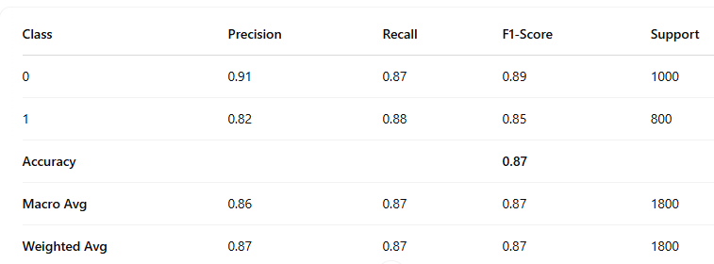

=====================================================

**Precision** measures the accuracy of positive predictions made by the model. In simple terms, it tells us, "Of all the instances the model predicted as positive, how many were actually positive?"

**Recall** measures the model’s ability to correctly identify all relevant positive instances. It answers the question, "Of all the actual positive instances, how many did the model correctly identify?"

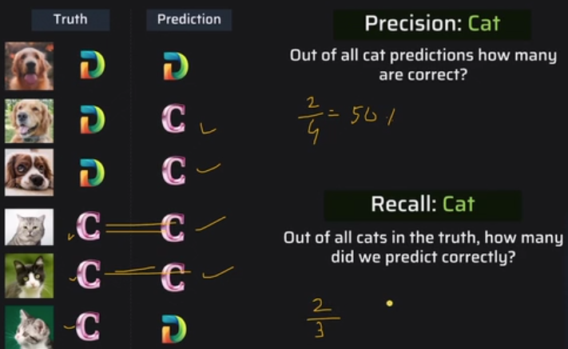

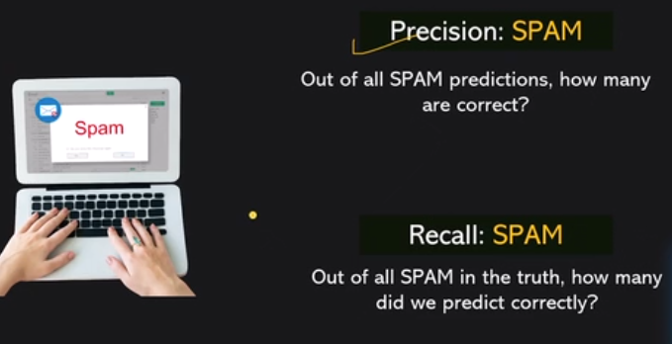



The **F1 Score** is the harmonic mean of precision and recall. It's a balanced measure, which is useful when you want to balance the trade-off between precision and recall.

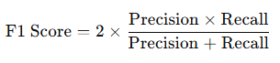

A higher F1 score indicates a better model, especially when dealing with imbalanced datasets.

========================================

**Support** refers to the number of actual occurrences of the class in the dataset (i.e., how many true instances of each class are in the data).

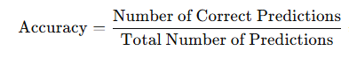

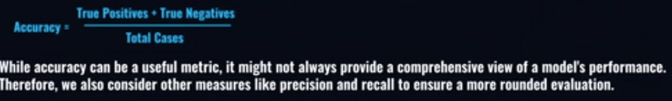

**TP (True Positive)**: Correctly predicted positive cases.

The email is **spam**, and the model correctly predicts it as **spam**.

**TN (True Negative)**: Correctly predicted negative cases.

The email is **not spam**, and the model correctly predicts it as **not spam**.

**FP (False Positive)**: Incorrectly predicted positive cases.

The email is **not spam**, but the model incorrectly predicts it as **spam**.

**FN (False Negative)**: Incorrectly predicted negative cases.

The email is **spam**, but the model incorrectly predicts it as **not spam**.

================================================================

